# 

**TABLE OF CONTENT**

# SUMMER TRAINING ASSIGNMENT REPORT

* Declaration
* Certificate
* Acknowledgment
* Abstract
* Introduction

Background

Objectives

Scope

* Training Experience

Company Overview

Role and Responsibilities

* Project Details

Background

Project Goal

Key Features

* Skills Required

Frontend Technology

Backend Technology

Database Management

* Conclusion

# 

# DECLARATION

I , SHIVANI VERMA bearing university roll no 2000560100100 , student of Bachelor of Technology ,Computer Science and Engineering, Babu Banarasi Das Northern Indian Institute of technology , Lucknow, hereby declare that the Summer Training assignment entitled “WINE QUALITY ANALYSIS” submitted by me, is a record of bonafide work carried out independently by me under the guidance of Mr Santosh Kumar sir, trainer at IITK Foundation for Advanced Continuing Education & Training (IFACET).

I assert that all the information presented in this report is factual and accurate to the best of my knowledge and is based on my own work and experiences during the summer training.

Any external sources of information, including data, literature, and references, have been duly cited and acknowledged in accordance with the prescribed citation style.

I have not submitted this report, or any part thereof, for any other purpose, including academic evaluation, and it has not been previously published.

# Shivani Verma

# 2000560100100

**CERTIFICATE**

# ACKNOWLEDGMENT

I would like to take this opportunity to express my heartfelt gratitude to all those who have contributed to the successful completion of my summer training and project.

First and foremost, I extend my sincere thanks to Santosh Sir , trainer at IFACET , for his unwavering support, guidance, and mentorship . Their expertise, valuable insights, and patience have been instrumental in shaping my learning experience.

I am also deeply grateful to him for his professionalism, and willingness to share their expertise have been invaluable in expanding my skillset and understanding of real-world projects.

I would like to acknowledge the support and encouragement of my fellow learners, whose camaraderie and collaborative spirit made the summer training journey both enjoyable and enriching.

Additionally, I extend my appreciation to my academic institution, Babu Banarasi Das Northern Indian Institute of Technology for providing me with the opportunity to enroll in summer training and for fostering an environment that encourages practical learning.

Finally, I wish to express my gratitude to my family and friends for their unwavering support, understanding, and encouragement.

This report would not have been possible without the collective efforts and support of all those mentioned above. Thank you for being part of this incredible journey.

# 

# ABSTRACT

This summer training report provides a comprehensive overview of my experiences and learning during my summer training program at IFACET. The training program, conducted from July 12th to September 15th, was an integral part of my academic journey at Babu Banarasi Das Northern Indian Institute of Technology . The primary objective of this training was to acquire practical skills in developing a Bug Tracking System using a console-based approach, with a strong emphasis on Python programming.

The report commences with an introduction to IFACET as the training authority and provides insights into the scope and objectives of the summer training. It delineates the structure of this report, encompassing sections that discuss the Bug Tracking System project overview, goals, methodologies, results, and concluding remarks.

A significant portion of the report is dedicated to a detailed examination of the Bug Tracking System project. It illuminates the technical challenges encountered during the development process, the methodologies and programming languages employed, and the pivotal role I played in contributing to both the frontend and backend aspects of this console-based system.

Noteworthy achievements and insights gained from this training encompass mastering Python for console-based application development, honing problem-solving skills, and gaining hands-on experience in database management, Python libraries.

This summer training not only enriched my technical proficiency but also deepened my appreciation for software development's real-world applications. It has equipped me with essential skills and knowledge, paving the way for a promising career in software development.

# INTRODUCTION

This report provides insights into my summer training journey, where I delved deep into the realms of data analysis, visualization, and database management. This immersive training experience has equipped me with a strong foundation in essential Python libraries, including pandas, matplotlib, numpy, and SQLite.

Python has the following libraries for data analysis:

* Pandas: Pandas is a data manipulation library that enables efficient data cleaning, transformation, and analysis.
* Matplotlib: Matplotlib is a data visualization library that allows the creation of informative and visually appealing plots and charts.
* NumPy: NumPy, a fundamental library for numerical computations in Python, was another key component of my training.

SQLite3: SQLite3 is a lightweight, serverless, and self-contained database engine, often used for local data storage and management.

**OBJECTIVES**

The main objectives of my training were to gain practical experience in frontend and backend technology, enhance my coding skills, and contribute to real-world projects. Key objectives include:

**Skill Development:** To enhance and apply academic knowledge and skills in a professional setting, fostering practical expertise.

**Industry Exposure:** To gain exposure to industry-specific practices, trends, and challenges.

**Networking:** To build professional networks and establish valuable contacts within the chosen field.

**Problem Solving:** To develop problem-solving and critical-thinking abilities by tackling real-world challenges.

**Career Exploration:** To explore and clarify career goals, interests, and aspirations within a specific industry or profession.

**SCOPE**

Data science is a highly dynamic and rapidly evolving field with a broad scope, and it is indeed in high demand. Data scientists analyze large datasets to identify patterns, trends, and valuable insights. Therefore, my training experience in python for data science will help me to contribute

by working on real life projects.

# TRAINING EXPERIENCE

This report documents my immersive training experience in mastering essential data science and database management tools: Pandas, Matplotlib, NumPy, and SQLite. Over the course of this training, I gained practical insights and hands-on proficiency in these fundamental technologies, paving the way for a strong foundation in data analysis and management.

**COMPANY OVERVIEW**

IITK Foundation for Advanced Continuing Education & Training (IFACET) is a company incorporated by IITK, to administer, operate and manage all activities related to continuing education for students, researchers, faculty, industry professional, institutions, industry and other individuals. It also undertakes all operational & administrative work both financial and non-financial with respect to E&ICT Academy (EICTA) established by IITK as a joint initiative of the Ministry of Electronics & Information Technology (MeitY).

**ROLE and RESPONSIBILITIES**

* Use Pandas to load, clean, and manipulate datasets for analysis.
* Apply NumPy for numerical computations and data manipulation tasks.
* Create informative visualizations using Matplotlib to convey data-driven insights effectively.
* Employ SQLite3 for local database management, including designing schemas, querying data, and integrating with Python applications.
* Tackle real-world data challenges by applying Pandas, NumPy, and SQLite3 to extract meaningful insights.
* Analyze data to identify patterns, trends, and outliers.
* Develop data-driven solutions to solve specific problems or answer questions using these tools.
* Troubleshoot and resolve issues that may arise during data analysis and visualization.

# 

**PROJECT DETAILS**

**Background**

The Bug Tracking System project was initiated in response to the growing need for efficient bug tracking in software development projects. It aims to streamline bug management processes and improve the overall software development lifecycle.

**Project Goal**

The primary goal of the Bug Tracking System is to provide a user-friendly platform that simplifies bug reporting, tracking, and resolution. By offering data analysis capabilities, it empowers project stakeholders to make informed decisions and continuously improve software quality.

**Key Features**

User Authentication: Role-based access control ensures secure and controlled access to the system.

Bug Reporting: Users can easily report bugs, providing detailed descriptions and attaching relevant files.

Project Management: Managers can create and assign projects, monitor progress, and allocate resources.

Data Analysis: Data analysis features provide insights into bug trends, helping teams identify areas for improvement.

.

# 

# MODULES IN PROJECT

# Admin Module

# 1. Manager

# 1. Add Manager Account

# 2. View Manager Account

# 3. Delete Manager

# 4. Update Manager Detail's

# 2. Employee

# 1. Add Employee Account

# 2. View Employee's Account

# 3. Delete Employee Account

# 4. Update Employee Detail's

# 3. View All Project

# 4. View Bug's Reports

# 5. Exit

# Manager Panel

# 1. Update Profile

# 2. Manage Project

# 1. Add Project

# 2. View All Projects

# 3. Delete Project

# 4. Update Project

# 3. Bug's

# 1. Add New Bug

# 2. View All Bug’s

# 3. Update Bug

# 4. Delete Bug

# 4. Exit

Employee Panel

1. Update Profile (ONLY OF HIMSELF)

2. Add Bug's Report

3. Update Bug status

4. View Bug's

5. Bug Detail’s

6. Exit

# SOURCE CODE SCREENSHOTS

# 

# 

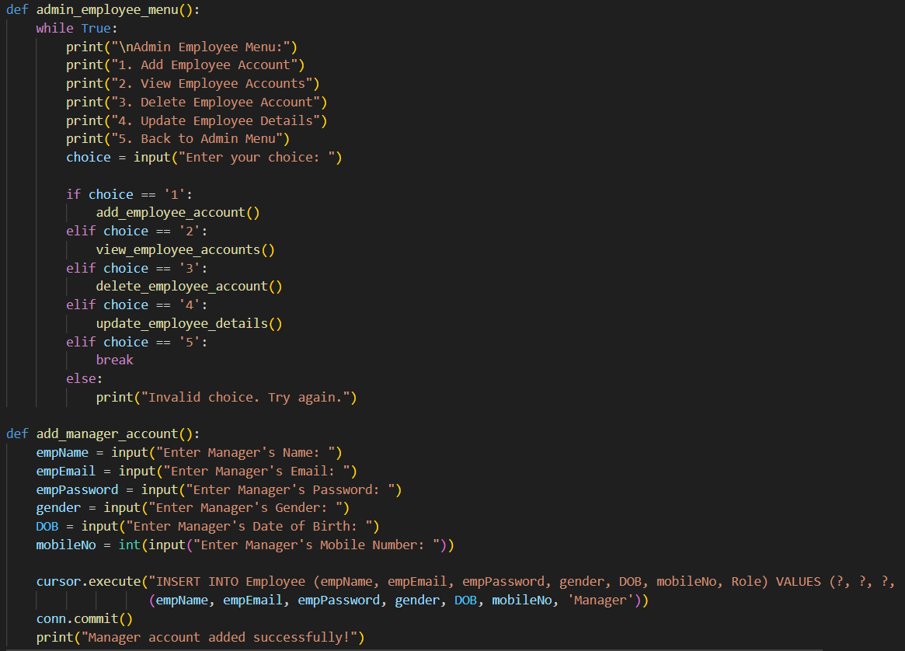

**OUTPUT SCREENSHOTS**

